**Front End Engineering-II**

Project Report

Semester-IV (Batch-2022)

Quiz app



**Supervised By:**  **Submitted By:**

Faculty-:Raveesh Samkaria Name-:Shreya Vashisht

Roll no-:2210990840

Group- G13

**Department of Computer Science and Engineering**

**Chitkara University Institute of Engineering & Technology,**

**Chitkara University, Punjab**

**TABLE OF CONTENT:**

|  |  |  |
| --- | --- | --- |
| Serial No. | Section | Page No. |
| 1 | Abstract | 3 |
| 2 | Introduction | 3-4 |
| 3 | Problem statement | 4-6 |
| 4 | File structure | 6 |
| 5 | codes | 7-12 |
| 6 | Result | 12-13 |
| 7 | References | 14-15 |

**Abstract-:**

The project involves the development of a Simple Quiz Application using HTML, Tailwind CSS, and JavaScript. The aim is to create an interactive platform where users can participate in quizzes by answering questions presented to them.

HTML Structure:

We have a div with the class app that serves as the main container.

Inside this container, there's another div with classes max-w-md, p-6, bg-white, rounded-lg, shadow-lg, and w-500, which provides styling for the quiz container.

Within this quiz container, we have the quiz title, question, answer options, and the "Next" button.

Tailwind CSS Styling:

We utilize Tailwind CSS classes to style various elements, including backgrounds, text colors, padding, rounded corners, and shadow effects.

Answer buttons (button elements) have specific Tailwind CSS classes to define their appearance, such as background color, hover effect, text color, font weight, padding, rounded corners, and shadow.

JavaScript Functionality:

We have a JavaScript function selectOption that is triggered when an answer button is clicked.

This function removes the selected class from all answer buttons and then adds the selected class to the clicked button, highlighting it to indicate selection.

This mechanism allows users to select an answer option.

Accessibility Consideration:

We ensure accessibility by removing the outline from focused elements using Tailwind CSS utility classes, ensuring a better user experience for keyboard navigation.

Responsiveness:

The layout is responsive, thanks to Tailwind CSS classes that adjust elements based on screen size.

Overall, this HTML document, styled with Tailwind CSS and enhanced with JavaScript, provides a visually appealing and interactive quiz interface where users can select answer options easily.

**Introduction-:**

In today's digital era, interactive learning tools play a crucial role in education, training, and knowledge dissemination. Quizzes are an effective method for evaluating comprehension, reinforcing learning, and engaging learners. However, creating and administering quizzes manually can be time-consuming and inefficient, especially in online or remote learning environments. Therefore, there is a growing need for automated and user-friendly quiz applications that facilitate seamless quiz creation, delivery, and assessment.

The project aims to address this need by developing a Simple Quiz Application using HTML, Tailwind CSS, and JavaScript. This application will provide educators, trainers, and content creators with a versatile platform for designing and conducting quizzes on various subjects. By leveraging modern web technologies, the project seeks to deliver a robust and intuitive solution that enhances the quiz-taking experience for users and streamlines the quiz management process for administrators.

**Problem Statement:**

The primary challenge addressed by this project is the lack of efficient and user-friendly quiz solutions tailored to the needs of educators and learners. Existing quiz platforms may be overly complex, lacking flexibility, or requiring specialized technical skills to operate effectively. Additionally, many available solutions may not offer the level of customization or control desired by educators when creating quizzes for their students.

Specific problems and pain points include:

Complexity: Existing quiz platforms may have a steep learning curve, making it challenging for educators to create and manage quizzes efficiently.

Limited Customization: Some quiz solutions may offer limited options for customizing quiz formats, question types, or scoring criteria, restricting educators' ability to tailor quizzes to their specific teaching objectives.

Accessibility: Many quiz platforms may not be accessible across different devices or may lack responsive design, hindering users' ability to take quizzes conveniently on desktops, laptops, tablets, or smartphones.

Scalability: Scalability may be a concern for quiz platforms that cannot accommodate a growing number of users, quizzes, or simultaneous quiz sessions, especially in educational institutions or corporate training settings.

Feedback and Assessment: Some quiz applications may provide limited feedback to users on their quiz performance or lack robust assessment features for analyzing quiz results and identifying areas for improvement.

By addressing these challenges, the Simple Quiz Application project aims to provide a user-friendly, customizable, and scalable solution that empowers educators to create engaging quizzes and enables learners to participate in quizzes seamlessly.

**File structure-:**

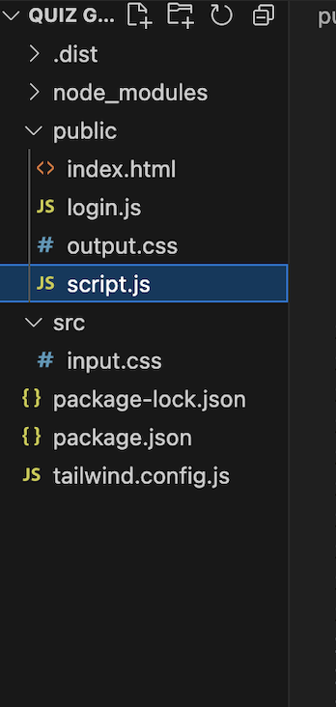



**Html code-:**

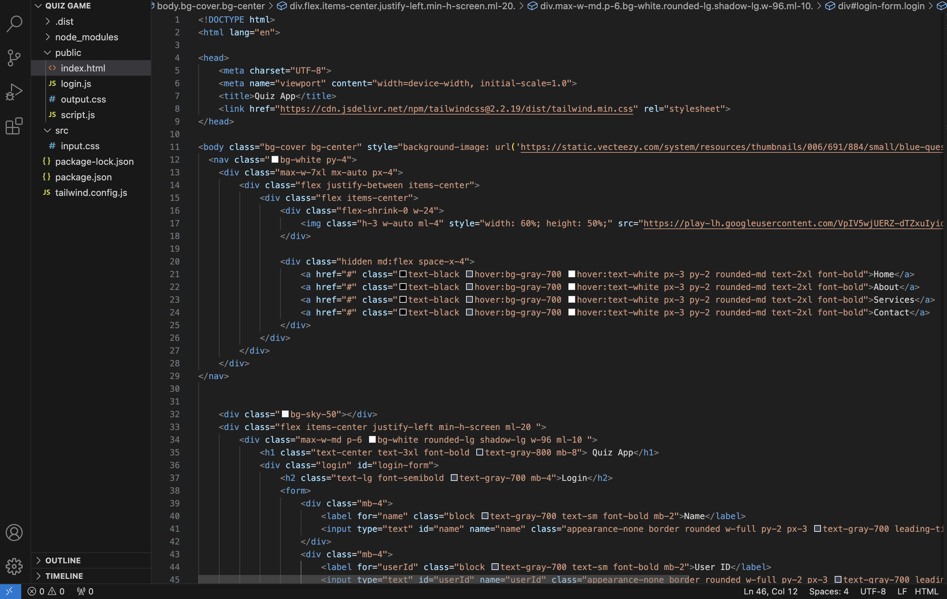

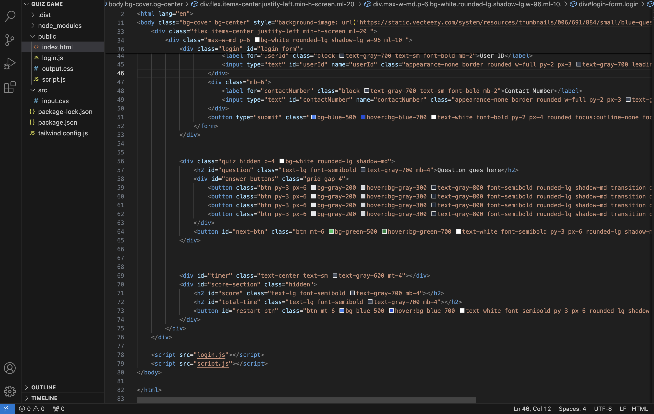

**Javascript code-:**

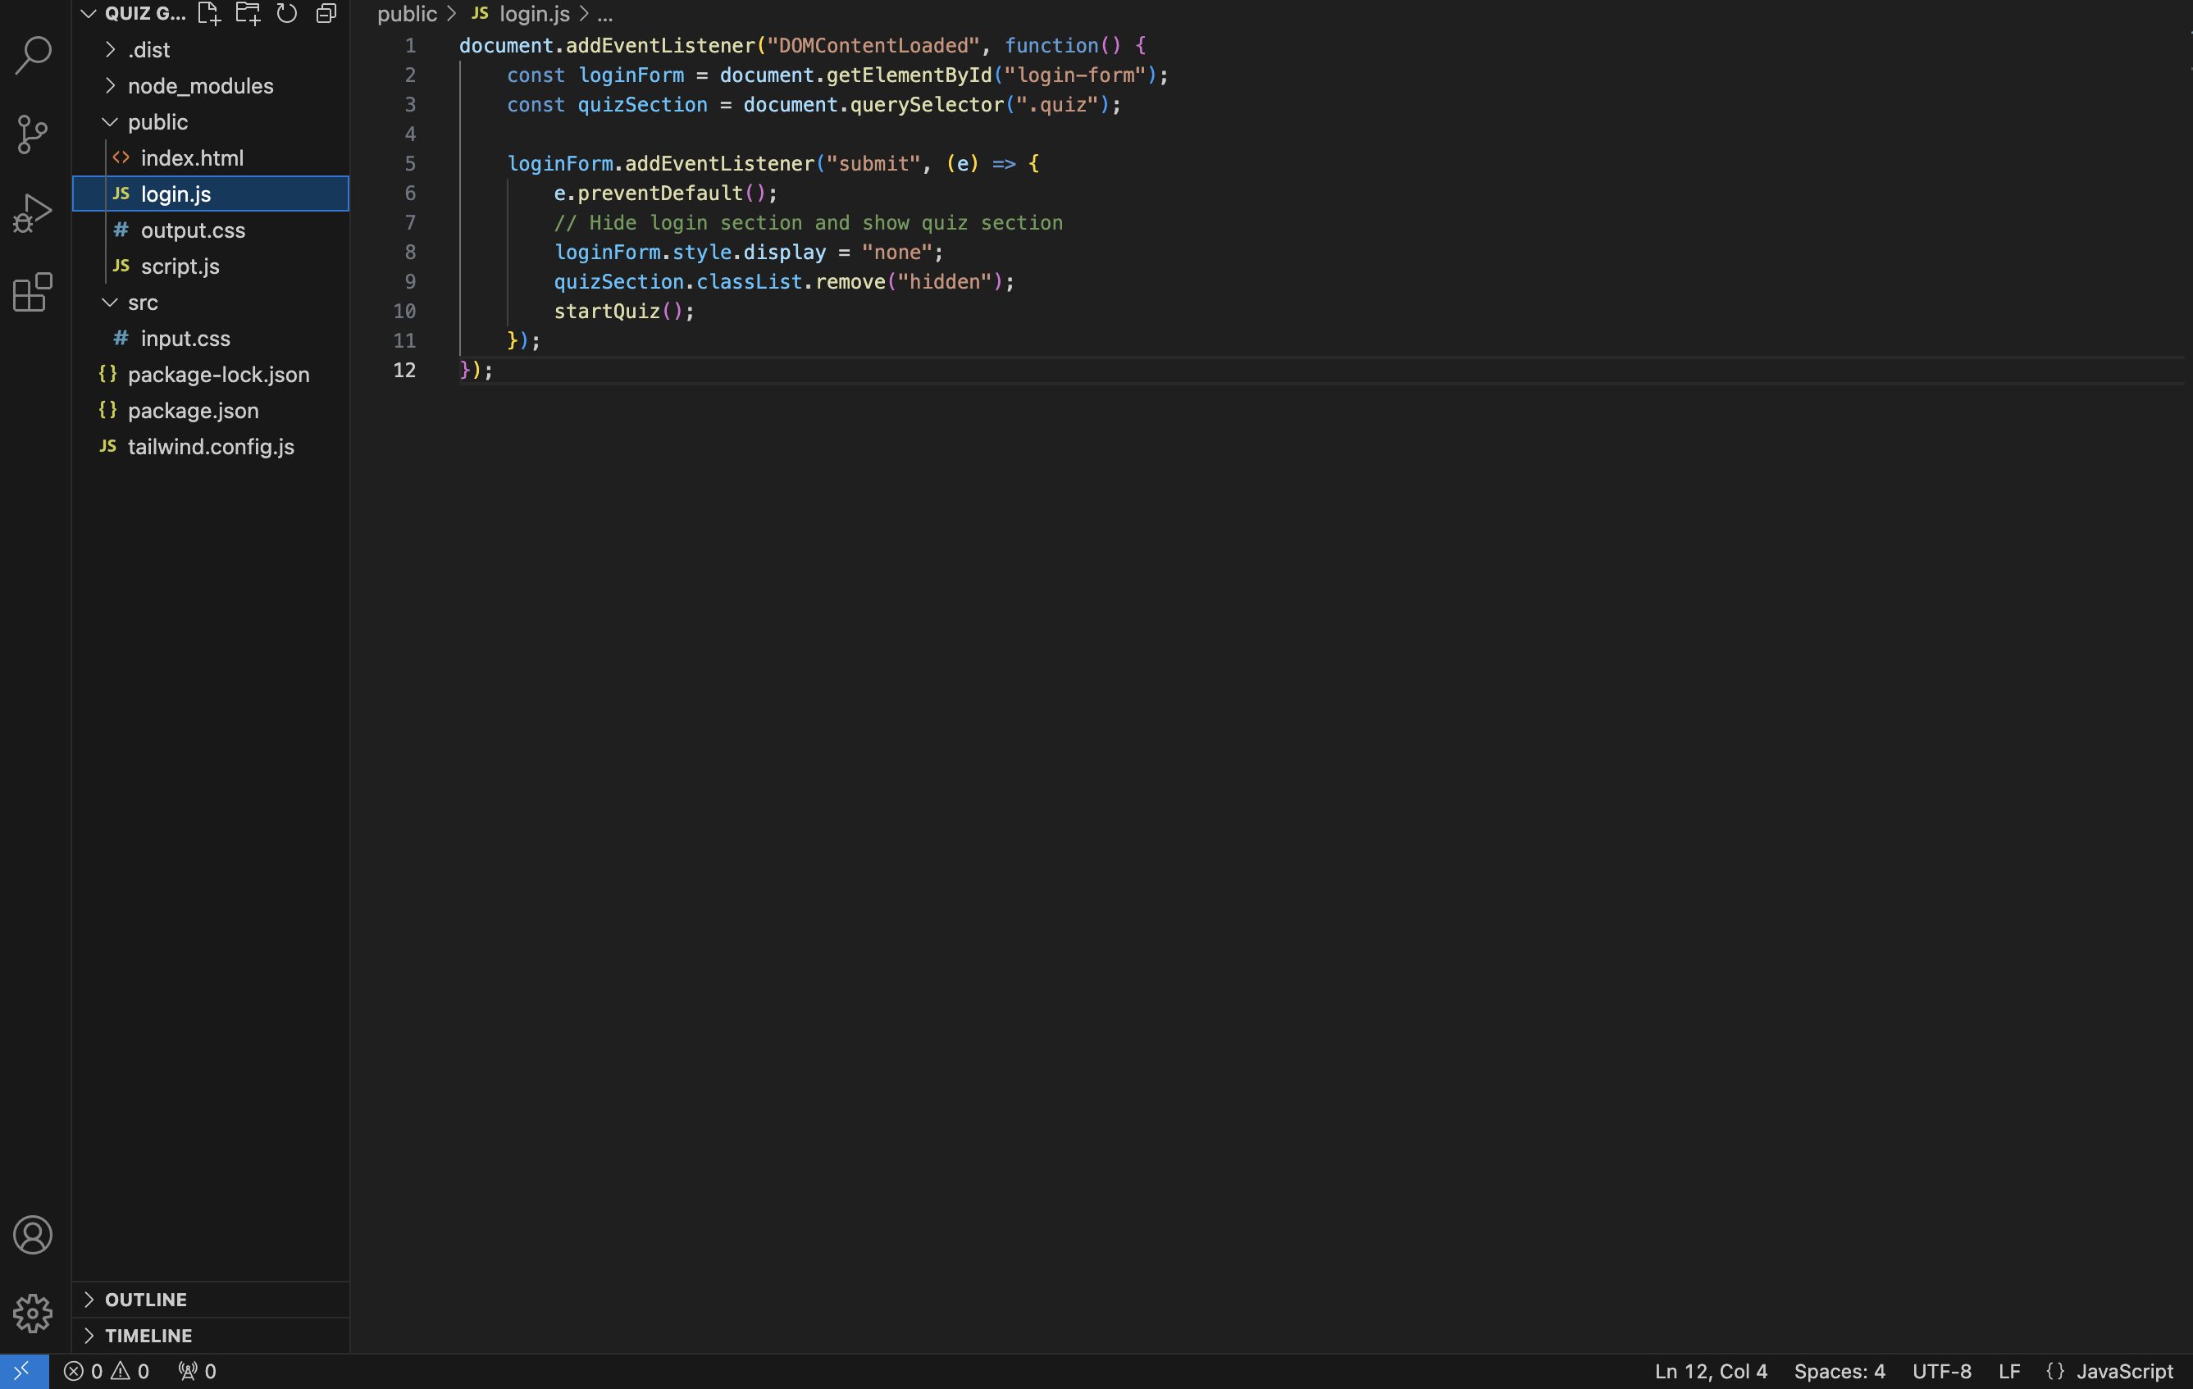

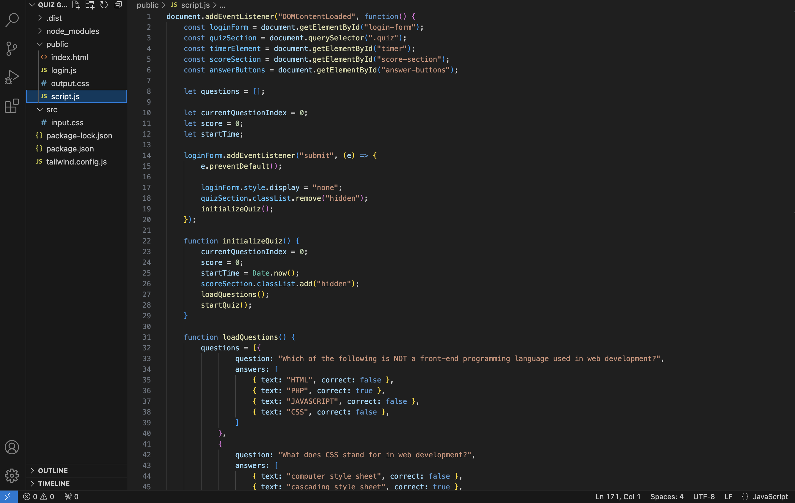

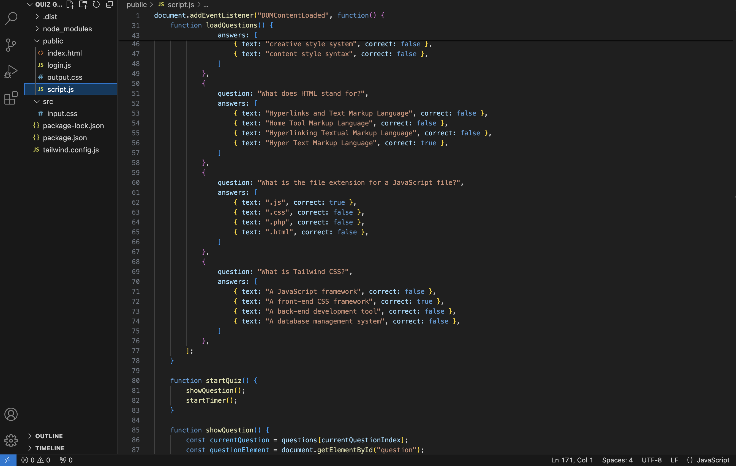

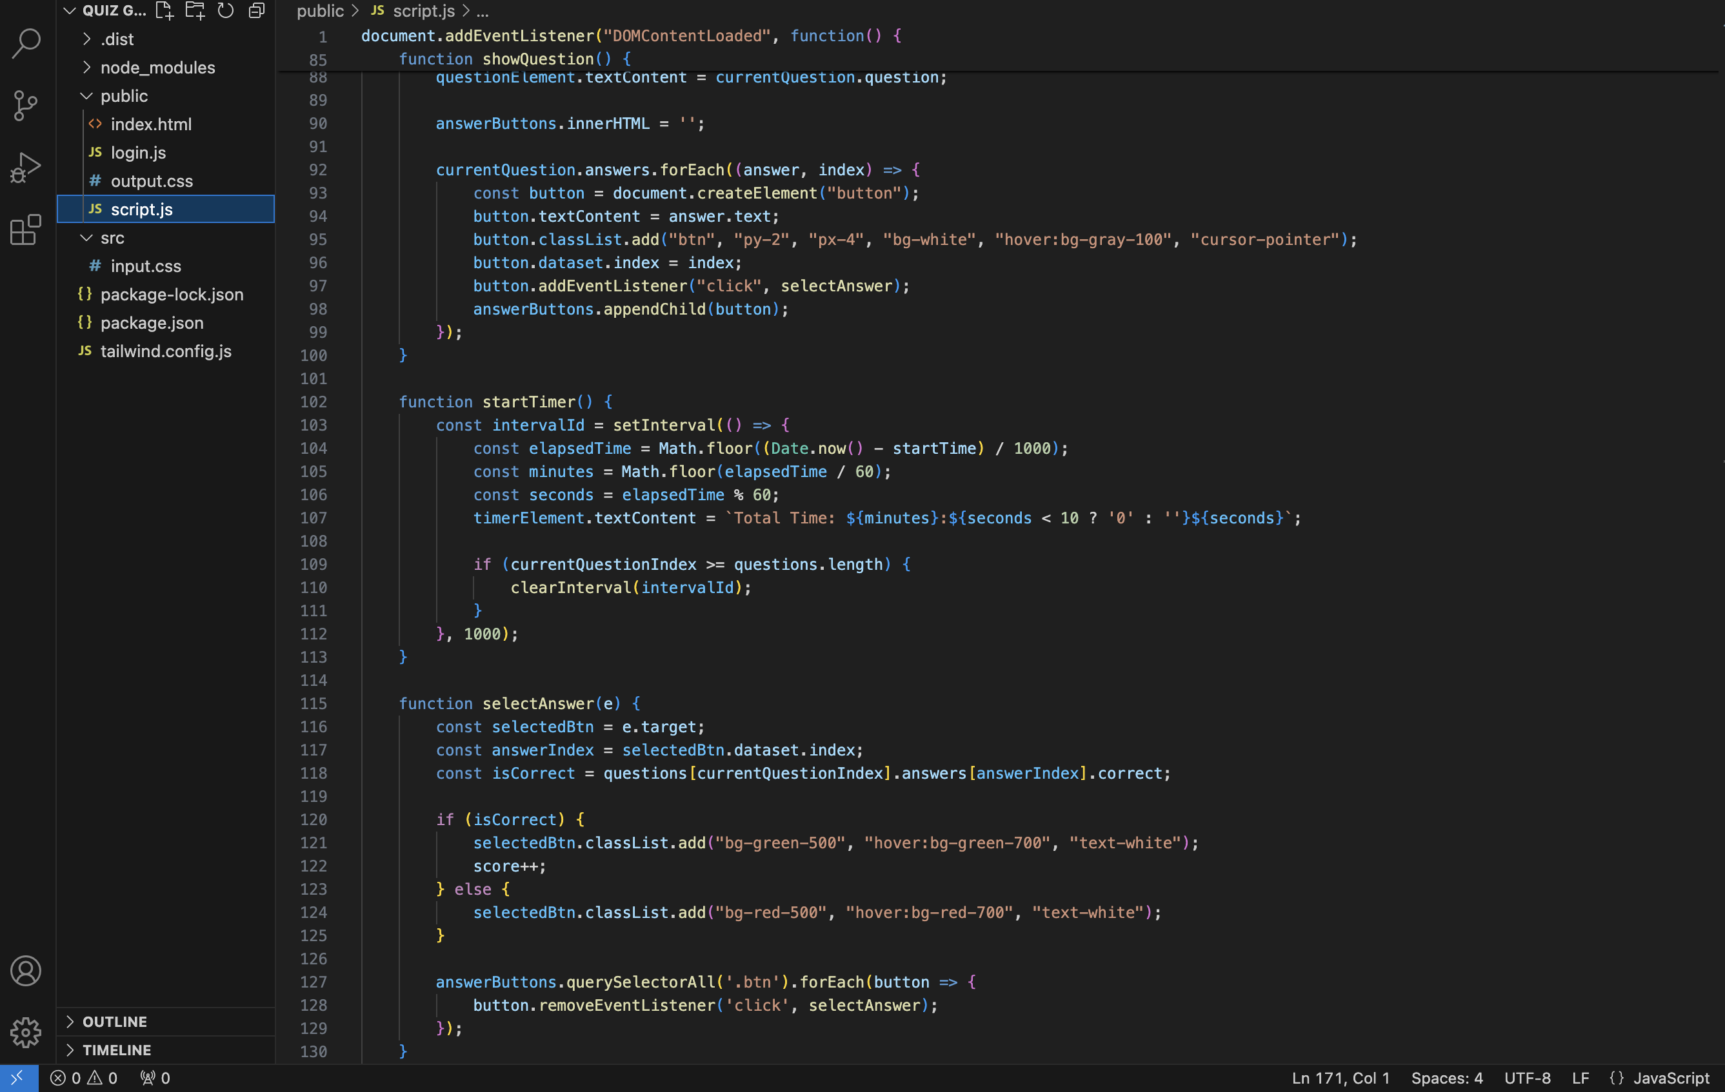

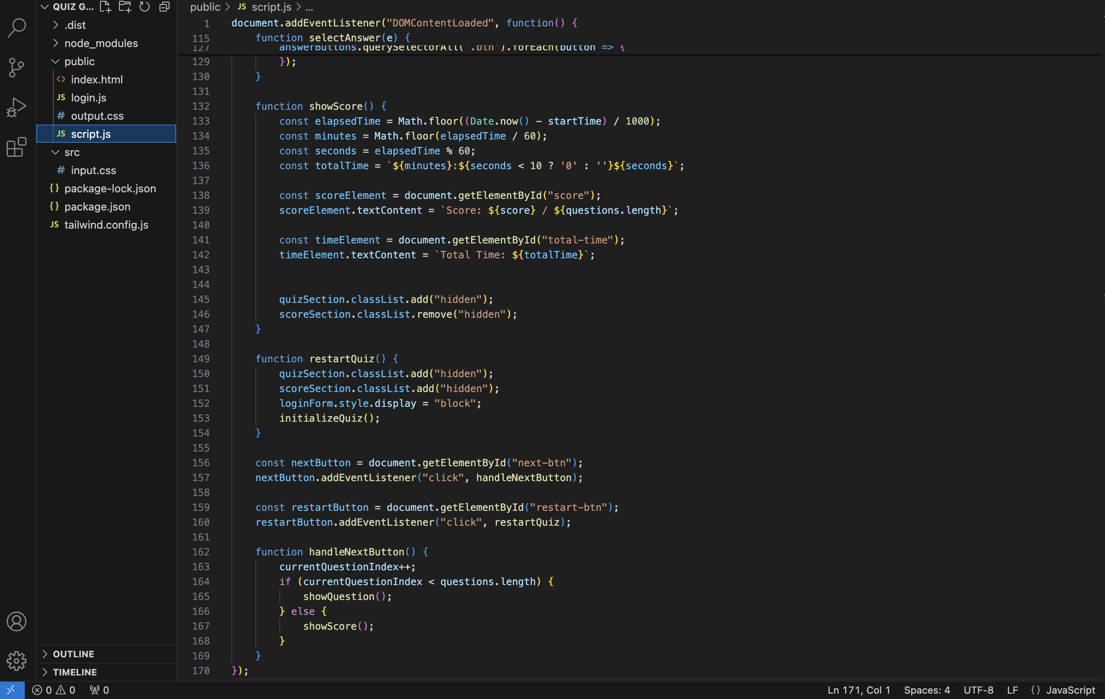

**Results:**



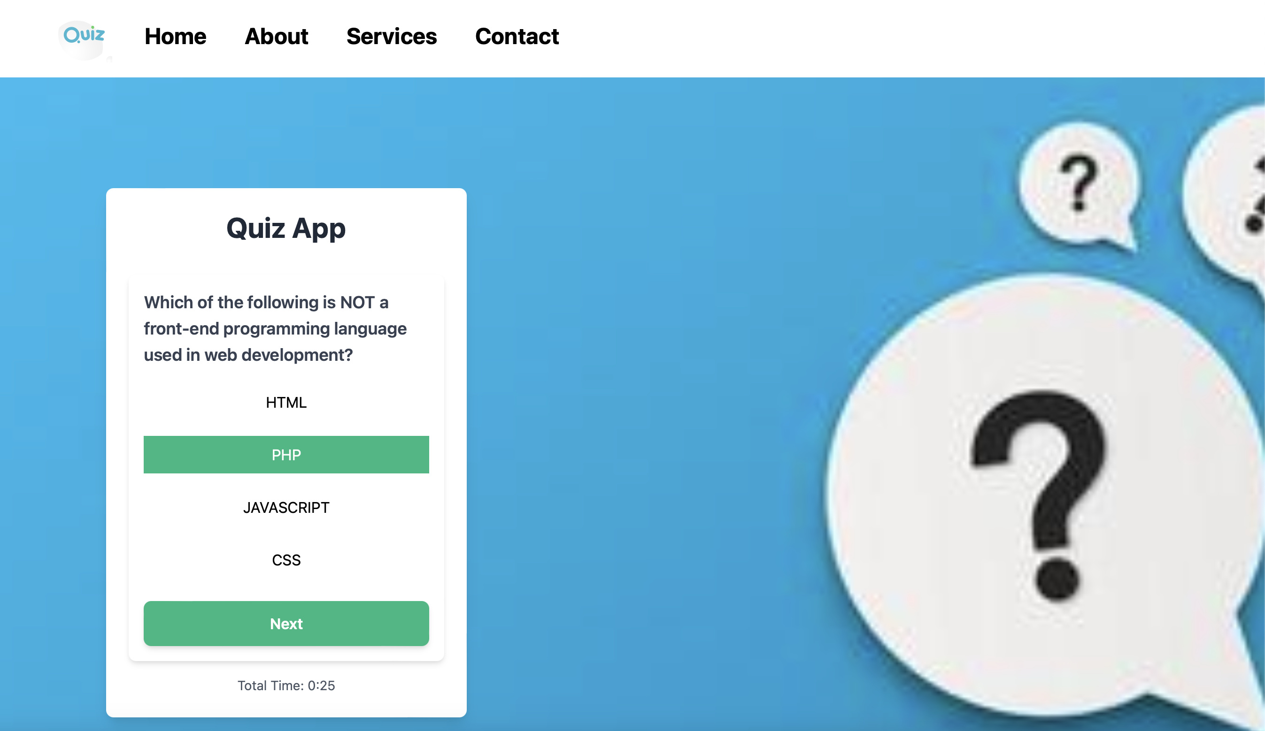

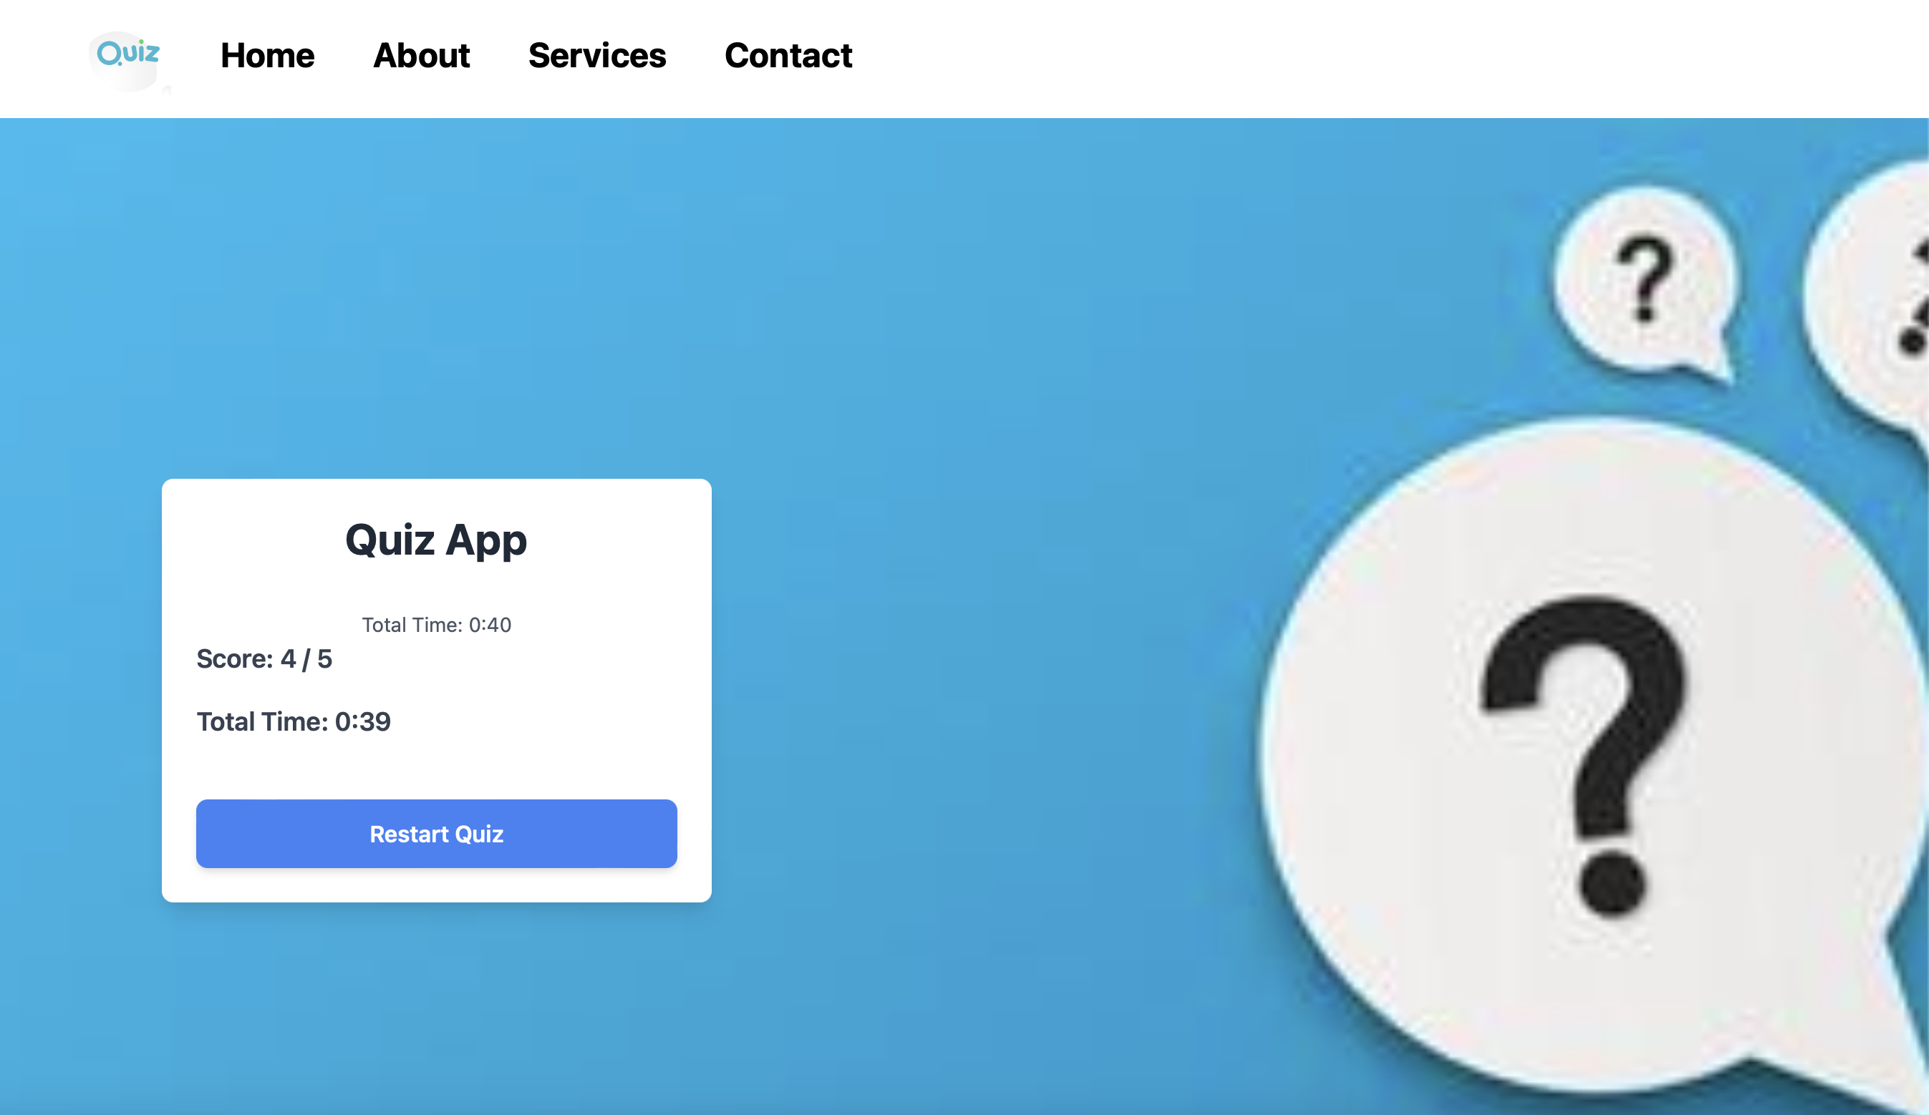

The development of the Simple Quiz Application has resulted in the creation of a user-friendly and interactive platform for conducting quizzes. The project successfully achieved its objectives of providing educators and learners with a versatile tool for designing, delivering, and assessing quizzes on various topics. Below are the key results and outcomes of the project:

Functional Quiz Interface:

The Simple Quiz Application features a functional and intuitive user interface, allowing users to navigate through quizzes effortlessly.

Users can access the quiz platform from different devices, including desktops, laptops, tablets, and smartphones, thanks to its responsive design.

Quiz Creation and Management:

Educators and content creators can easily create quizzes by adding questions, answer options, and scoring criteria through the application's interface.

The quiz management system allows administrators to organize quizzes, track user progress, and analyze quiz results effectively.

Interactive Quiz Experience:

Users can participate in quizzes by selecting answer options presented to them, with immediate feedback provided on their responses.

The application enhances user engagement through interactive elements such as clickable answer buttons and dynamic question presentation.

Customization Options:

The Simple Quiz Application offers customization options for quiz formats, question types, and scoring parameters, enabling educators to tailor quizzes to their specific teaching objectives.

Users have the flexibility to customize the visual appearance of quizzes using predefined themes and styling options provided by the application.

Scalability and Performance:

The quiz platform is designed to scale effectively to accommodate a growing number of users, quizzes, and simultaneous quiz sessions.

Performance optimizations ensure that the application maintains responsiveness and efficiency, even under heavy user load.

Overall, the Simple Quiz Application has proven to be a valuable tool for educators, trainers, and learners alike, enhancing the quiz-taking experience and supporting effective learning outcomes. With its user-friendly interface, customization options, and robust functionality, the application contributes to the advancement of online education and assessment practices. Future enhancements may include additional features such as timer functionality, multimedia support, and integration with learning management systems for seamless quiz delivery and administration.

**References-:**

* **Html -:**

**1. w3schools-:**

**(**[**https://www.w3schools.com/html/**](https://www.w3schools.com/html/)**)**

**2.Html tutorial-:**

**(**[**https://www.tutorialspoint.com/html/index.html**](https://www.tutorialspoint.com/html/index.html) **)**

* **Tailwind-:**

**1.Tailwind CSS-:**

**(**[**https://tailwindcss.com/**](https://tailwindcss.com/)**)**

**2.Geeksforgeeks-: (**[**https://www.geeksforgeeks.org/introduction-to-tailwind-css/**](https://www.geeksforgeeks.org/introduction-to-tailwind-css/) **)**

* **Javascript-:**

**1.w3school- (**[**https://www.w3schools.com/js/**](https://www.w3schools.com/js/)**)**

**2.wikipedia-:**

**(**[**https://en.wikipedia.org/wiki/JavaScript**](https://en.wikipedia.org/wiki/JavaScript)**)**